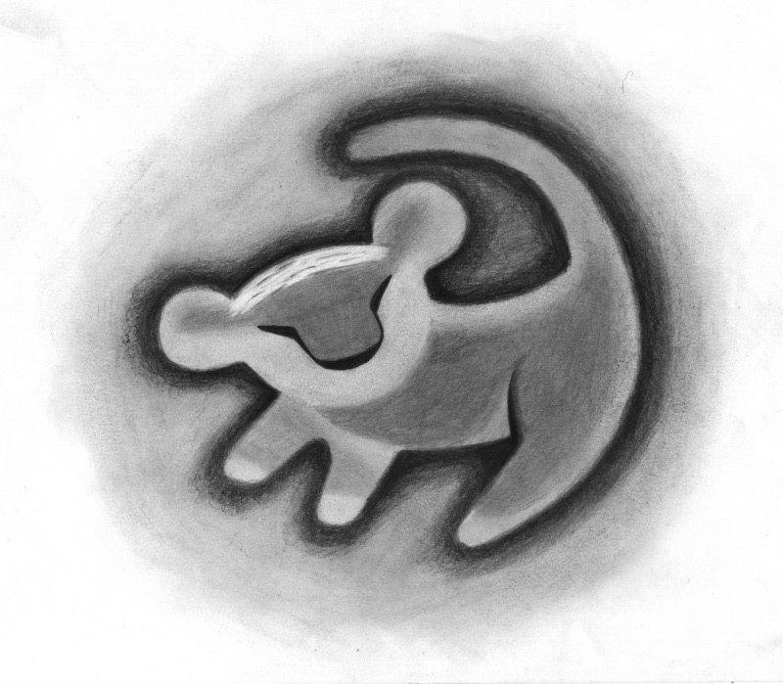
DRAMA CLUB/THE LION KING JR. AUDITIONS:
Thursday September 15th & Monday September 19th
(Drama Club rehearses Thursdays from 4:20pm-6pm beginning October 6th, 2016)

Please sign up in the front office for your auditions beginning on Wednesday September 7th-Wednesday September 14th. All students should sign up for two auditions (one for dancing and one for singing). Students should pick up a STUDENT AGREEMENT FORM. Students may not audition without this signed form. It also serves as your audition pass. Please review the following requirements so that you can be the most prepared for your auditions:

Thursday: Dancing
- What to prepare: nothing! Just come with you and a good attitude!
- This is a large group audition. Come dressed in clothing that you can move in with shoes appropriate for movement (no flip flops).
- Meet in the theater after school at 4:20pm. The audition will conclude by 6pm, but some students may be done sooner.
- Be prepared to learn a short movement routine (easy). Students will audition in groups of five for a panel of judges.
- Once students have auditioned, they are dismissed.
- All students must have a pass to audition. The pass is your STUDENT AGREEMENT FORM.

Monday: Singing and Acting
- What to prepare: students should sign up for their own 3 minute audition in the front office. Students should prepare about 3o seconds of a song that showcases their singing voice, to sing a cappella, for a panel of judges in a private audition (this is kind of like an American Idol audition)
- Students will also do a cold reading of a piece of script in this audition. There is nothing to prepare for this, but just know this is part of your audition.
- Students may stay after school in the holding room (the chorus room) or return through the bus port doors for their auditions. Please be early for your audition, if you are late, you might not get to audition. The holding room is a QUIET ZONE.
- All students must have a pass to audition. The pass is your STUDENT AGREEMENT FORM.

Please direct all questions about the auditions to:
lauren.hemmings@cobbk12.org

